Clare Primary School

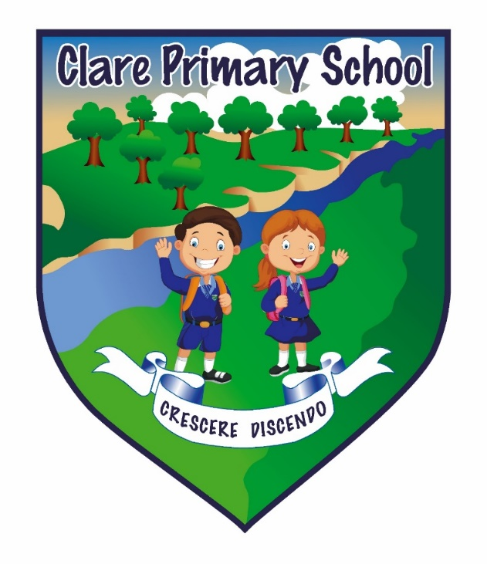

Relationships, Sexuality and Education Policy

Date the policy came into effect
Date of next policy review
Name of person responsible for this policy | Principal, BOG, Staff, Parents, Pupils
Other related policies | Attendance, Complaints, GDPR, Educational Visits, ICT and e:safety, Health and Safety, Pastoral Care, Use of Reasonable Force and Safehandling, Safeguarding
Issued to | Staff, BOG, Parents

Relationships and Sexuality Education (RSE) Policy

Definitions
RSE – Relationships and Sexuality Education
PDMU –Personal development and Mutual understanding
DENI – Department of Education Northern Ireland
SEN – Special Educational Needs

Purpose of the RSE Policy
Schools are diverse communities and places that are an important part of their community both locally and nationally. Clare Primary School is a coeducational controlled school with pupils ranging from age 4/5 in primary 1 to age 11 in primary 7. There are currently 127 pupils and 18 staff working in the school environment.

Part of a pupil’s place in our school and in their community will naturally involve the development of their understanding of friendly, family and wider social relationships. School, in partnership with parents and outside agencies, will provide opportunity for pupils to develop an age appropriate knowledge and understanding of sexuality and relationships.

Our RSE policy reflects our school ethos, vision, values and our PDMU (Personal Development and Mutual Understanding) curricular framework. The policy explains how we will monitor and evaluate the teaching and learning of RSE and how we share this responsibility with our parents and wider community. This policy document will help form part of the wider self-evaluation process of the school.

RSE forms part of our PDMU whole school curricular framework. This is integrated within the wider school curriculum and complements and overlaps with the general Christian ethos and life of the school. Pupils will experience age appropriate opportunity to learn about relationships, bodily development and sexuality in classroom activities taught through the thematic strands of PDMU including: ‘Self-Awareness; Feelings and Emotions; Health, Growth and Change; Safety; Relationships; and Similarities and Differences.

The policy is in written line with DENI circulars 2013/16 and 2015/22. This policy is also written with relation to our other school policies including, but not only, Pastoral Care, Safeguarding/Child Protection, Special Educational Needs, e:Safety, Behaviour and Citizenship, PDMU, and Teaching & Learning. This policy is to be reviewed on a 2 year cycle by the school leadership, Board of Governors, pupils and parents. It will be displayed on the school website. There will also be a trifold shortened version of the RSE policy sent home every 2 years.

Aims of the RSE Policy
The aims will cover Primary 1 – 7 but not every Year Group will cover all aspects of the aims written below.

We aim to:
- Provide a planned, age appropriate scheme of work, designed to capitalise on the fascination and interest that children have about themselves, their own growth and development;
- Offer reassurance that such changes are normal and natural;
- Provide the opportunity for pupils to express themselves within a trusted and safe environment, following agreed ground rules;
- Reassure children of their value and self-worth including aspects of dignity, self- respect and self-restraint;
- Help them to have a responsible attitude towards personal relationships including mutual respect and care;
- Develop sensitivity towards the needs of others and provide knowledge of loving relationships;
- Inform children on matters of personal hygiene and related health and healthy lifestyle issues;
- Encourage exploration of values and moral issues taking into account physical and moral risks associated with certain behaviour including alcohol and drug abuse;
- Educate against discrimination and prejudice and help prepare children to make informed choices about relationships;
- Teach pupils the skills of making good choices about relationships;
- Teach pupils the skills of and reasons for making the safest and best choices about e:Safety;
- Provide pupils with skills to understand and articulate what makes them feel happy and safe;
- Help prepare pupils for the physical and emotional changes of growing up;
- Help pupils develop self-expression and their ability to communicate their feelings and emotions;
- Develop within our pupils an attitude of respect for all others;
- Teach pupils to understand the value of stable family life, marriage, love, care and respect;
- Teach the importance of appropriate physical contact between people and what to do if they are worried about this;
- Ensure that children are able to understand and not misinterpret the information they acquire and to provide contexts where they are able to consider and evaluate the information they receive;
- Provide an overview of our planned, age appropriate, scheme of work;
- Provide an overview of how teaching and learning in RSE is monitored and evaluated to staff, governors and parents;
- Raise awareness and promote agencies who can inform and help pupils and parents throughout their lives;

Home/School Partnership and Pupil Withdrawal
We believe that parents have the primary role in the delivery of relationship and sexuality learning at home. We therefore actively encourage the need to discuss RSE issues at home without embarrassment. Central to our RSE is the development of pupils’ self-esteem. If young people feel positive and good about themselves they are more likely to take care of themselves, think positively of other people and therefore, develop non-exploitative, caring relationships. They are also less likely to be exploited by others. It is hoped therefore that the school curriculum and the ethos of the school complements and enhances home teaching and values, giving due regard to the value of family life, marriage and loving stable relationships.

Under the 1993 Education Act parents have the right to withdraw their child from part or all of our Relationships and Sexuality Education. Parents should discuss this matter with the Principal. Parents should make it clear which aspect of the programme they do not wish their child to participate in and put this in writing. Resources and information regarding further support and help will be made available.

We would ask parents to reinforce the information and values being taught in Clare Primary School. As written in our e:Safety policy, we ask parents to monitor and be responsible for e:Safety at home.

SEN
Pupils with specific difficulties will be treated with sensitivity and teaching will be reasonably adapted according to their needs in relation to available resources. Parents with a child with SEN will be consulted, as appropriate to the child’s need, as to their preferences regarding RSE. RSE however, in a mainstream school should ideally be provided for all children including those with physical, emotional or learning difficulties.

Disability
If the school has any children with disabilities who require special assistance their needs will be fully considered. Their parents will be consulted.

Confidentiality and safeguarding
Pupils and staff who report anything of an intimate nature will be fully supported via the Child Protection/Safeguarding Policy and procedure in school. All school staff are trained in Child Protection/Safeguarding each September. We have a school Safeguarding team (see Safeguarding leaflet or school website for information). The Designated Teacher is Mrs Martinn and the Deputy Designated Teacher is Miss Lindsay.

Whole School approach to teaching RSE
It is our belief that RSE is the responsibility of all staff and should be an integral part of the teaching and learning process in order to prepare children to cope with the physical and emotional challenges of growing up. It should be provided for all children including those with physical, emotional or learning difficulties. RSE should develop decision-making and communication skills, foster self-esteem, self-awareness and respect for oneself and others.
Questions will be responded to as they arise in a straightforward way, giving simple and correct information, using correct terminology for body parts and functions appropriate to the age of the child.

Staff Rights
School staff have the right not to feel under pressure to answer difficult questions on the spot or answer questions that they believe to be matters relating to Child Protection/ Safeguarding. Staff may use distancing techniques such as referring the question to a question box or communicating with the Principal, Safeguarding team or parents if appropriate, allowing time for discussion about the most suitable way to answer what has been posed. Again, any concerns arising regarding a child or any indications that a child or children are at risk of harm or in danger will be discussed with the school Safeguarding Team in line with school policy.

The main delivery of RSE is through Personal Development Mutual Understanding (PDMU), but some aspects are also taught through other subject areas such as WAU (World Around Us), RE (Religious Education) and PE (Physical Education). It is taught by the class teacher, and where possible supportive outside agencies including NSPCC, Love for Life and on occasion possibly the Health and Social Care Trust.

Monitoring and reviewing
In school the Safeguarding Team, PDMU co-ordinator and the Principal will monitor the teaching of RSE. The school’s governing body are updated on the progress of RSE and will review the school policy along with the school Principal and relevant staff members as well as parents. When the policy is reviewed the governing body will give serious consideration to any comments from parents about the RSE programme, and make note of all such comments.

RSE will also always feature in the 3 year school development planning.

Role of Principal
It is the responsibility of the Principal to ensure that:
- Policy and practise is developed in accordance with good practice guidelines and recommendations;
- Teaching RSE/PDMU is carried out effectively in each classroom;
- The policy is reviewed and monitored and approved by governors;
- Staff and parents are informed about policy;
- Staff receive appropriate training and support;
- External agencies adhere to the school policy.

Complaints Procedure
In the unlikely event that parents have any cause for concern about the RSE Policy they will be asked to come into school to resolve the problem in line with the school Complaints Procedures.

Useful websites
www.saferinternet.org.uk
www.thinkuknow.co.uk
www.childnet.com/teachers
www.kidsmart.org.uk
www.nspcc.org.uk
www.safertoknow.info
www.exceedingexpectations.org.uk
www.endbullying.org.uk

Other complementary school policy documents
e:Safety & Acceptable Use
Safeguarding
Pastoral Care
Behaviour and Citizenship
PDMU
Teaching and Learning
SEN
Complaints

